W-20

**YEAR 12 PHYSICS**

**ASSIGNMENT 7 - STANDARD MODEL**

**Name:** **Mark:**

1. Sirius appears as the brightest star in the night sky. It is actually a binary star consisting of Sirius A, a large blue-white star, and Sirius B, a white dwarf. Our view of the Sirius star system is such that there are times when Sirius B is coming toward us and times when it is going away from us. When Sirius B is moving toward us:

(a) Sirius A will be (1 mark)

A   moving toward us, relative to Sirius B.

B   moving away from us, relative to Sirius B.

Your answer

(b) Compared to the speed of light approaching us from Sirius A, the speed of the light

approaching us from Sirius B will be (1 mark)

A   the same.

B   less.

C   greater.

Your answer

(c) An astronomer views a spectrum of the visible light from Sirius B. Describe **one** feature

of this spectrum that would indicate Sirius B is moving toward the astronomer.

(2 marks)

(d) Big Bang theory predicts the Sirius system should be (1 mark)

A   moving toward us.

B   moving away from us.

C   keeping a constant distance.

2. Two spaceships, ‘Albert’ and ‘Max’ are travelling toward each other. Each has a speed of 0.750*c* as measured in the Earth’s reference frame.

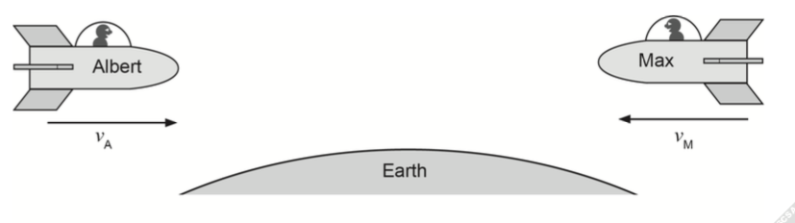

Calculate the velocity of Max as measured by the crew on spaceship Albert. (4 marks)

3. Muons are created in the upper atmosphere with speeds of 0.990*c* or more. Their average lifetime is 2.20 μs measured at low speeds in the laboratory. A simple calculation shows that most should only travel about 660 m before decaying. Thus, very few muons should ever reach sea level.

(a) Using relativistic mechanics, calculate how far a muon can travel according to an

observer on Earth. (4 marks)

(b) Explain why many more muons reach the surface of Earth than predicted classically.  
 (2 marks)

4. An electron microscope creates a coherent beam of electrons which then travels through two narrow slits. The resulting interference pattern is detected on a photographic plate. The speed of the electrons is 1.00% of the speed of light.

(a) Show that the de Broglie wavelength of the electrons used is 2.43 × 10-10 m.

(2 marks)

(b) Describe what you expect to see on the photographic plate. (2 marks)

(c) Explain the behaviour of the electrons in this experiment. (2 marks)

(d) If the experiment were to be repeated using protons, at what speed would a proton need to travel to have the same de Broglie wavelength as the electrons? (2 marks)

(e) Calculate the potential difference required for the electron microscope to accelerate the electrons to 1.00% of the speed of light. (4 marks)

5. The elementary particles of the Standard Model are shown in the data sheet.

(a) If up (u) and down (d) quarks are the building blocks of nucleons, suggest a combination of three quarks that would produce a

(i)   proton: (1 mark)

(ii)   neutron: (1 mark)

(b) Identify **one** type of gauge boson and describe its role in the nucleus. (2 marks)

(c) Muons and taus are created in a particle accelerator and accelerated to the same velocity. Sketch their paths if the two particles were directed into a magnetic field as

shown in the diagram below. (4 marks)

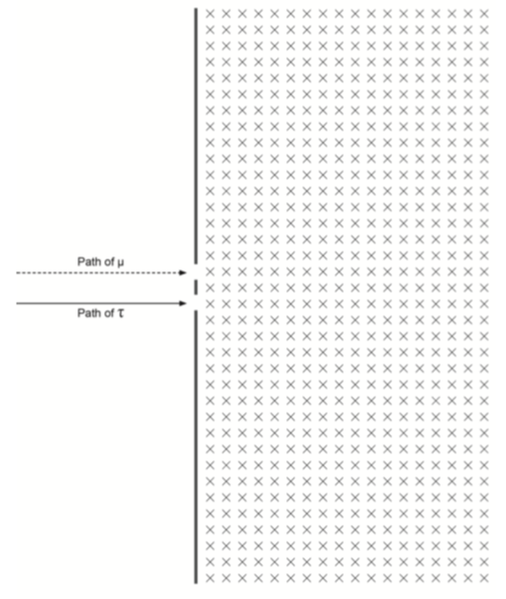

6. A deep-space probe moves away from the Earth with a speed of 0.550*c*. In its frame of reference, an antenna on the probe rotates every 23.0 s. Calculate the time for **one** rotation when observed from Earth. (2 marks)

7. Photons with sufficient energy can, on interacting with matter, produce an electron-positron pair.

(a) (i) Show that the lepton number is conserved in such an interaction. (3 marks)

(ii) Given *E = mc2*, determine the minimum frequency of a photon that could produce an electron-positron pair. (4 marks)

A neutron will decay into a proton and an electron as shown in the equation below.

n → p+ + e- + ?

(b) (i) Demonstrate that the baryon number is preserved in the way that the equation is written above but the lepton number is not. (2 marks)

(ii) Identify the third particle in the decay to ensure that the lepton number is conserved. (1 mark)

8. Use the Standard Model in the Formulae and Data Booklet provided to answer the following questions.

(a) Identify the elementary particle responsible for mediating each of the following phenomena and complete each sentence. (3 marks)

The elementary particle responsible for the weak force is the

The elementary particle responsible for the strong force is the

The elementary particle responsible for the electrostatic force is the

A table of the characteristics of the four forces can be drawn as shown.

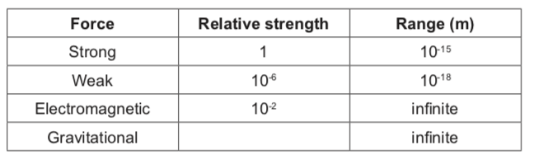

(b) (i) The relative strength of the gravitational force would **best** be described as: (1 mark)

A  1012.

B  10-4.

C  10-12.

D  10-38.

Your answer

(ii) Give an appropriate reason for your choice. (2 marks)

(c) The order of evolution of forces directly after the big bang is best thought of as:

(1 mark)

A  gravitational first, then strong and weak last.

B  weak first, then strong and gravitational last.

C  strong first, then weak and gravitational last.

D  simultaneous, i.e. all forces were created at the same moment.

Your answer

(d) A graviton is the proposed particle that mediates gravity but is as yet undiscovered. Suggest a characteristic for the graviton and give a reason why. (2 marks)

9. Positron emission topography (PET) is a high-resolution gamma ray medical imaging technique and is useful for scanning soft tissue of the human body.

Fluorine-18 is a radioisotope commonly used in PET. Fluorine-18 is produced via the proton bombardment of the stable isotope oxygen-18 in a cyclotron.

The unstable fluorine-18 used in PET decays back to oxygen-18 as shown in the equation below.



(a) Use the equation above to describe how the nucleus of the fluorine-18 decays to produce oxygen-18. Name the other particles produced. (3 marks)

(b)   Name the force and force particle that mediate the interaction described in part (a).  
 (2 marks)

Force:

Force particle:

(c)   Use your knowledge of the Standard Model to prove that this emission obeys the conservation of baryon number and charge. Assume all quarks have a baryon number

equal to 1⁄3. (4 marks)

One of the products from the decay of fluorine-18 then interacts with the electrons of the human body to create two gamma rays that travel in opposite directions to each other. These gamma rays are detected and used to form images of tissues in the human body.

(d) Discuss the interactions that must occur to produce two gamma rays travelling in opposite directions to each other. (5 marks)

10. In 2012, scientists at the European Organisation for Nuclear Research (CERN) in Switzerland claimed to have found the Higgs boson. They measured its rest energy to be 126 GeV. Show that the mass of the Higgs boson is 2.24 × 10−25 kg. (4 marks)

11. If we plot the de Broglie wavelength of a subatomic particle against its momentum, we get the graph shown below. This applies to velocities less than 5% of the speed of light.

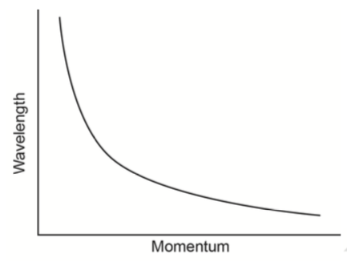

(a)   Give a possible relationship between wavelength and momentum based upon the shape of the graph. (1 mark)

(b)   Describe how the data used to generate the graph could be reorganised to produce a straight-line graph. (2 marks)

(c)   What would the gradient of the straight-line from part (b) represent? (1 mark)

(d)   Ignoring relativistic effects, calculate the momentum of a particle with a wavelength of 2.50 × 102 nm. (4 marks)

12. Chloe is piloting the spaceship *Antilles*. It is 1.10 km long and travelling at 0.800*c* past a spaceport controlled by Zhang. Zhang needs to measure the speed of passing spaceships. Chloe steers the spaceship between two beacons 1000 m apart as measured by Zhang. The beacons are placed parallel to the *Antilles’* path. Both Chloe and Zhang start their timers when the front of the *Antilles* reaches the first beacon.

(a)   Calculate the time elapsed on Zhang’s clock (as observed by Zhang) when the front of *Antilles* reaches the second beacon. (1 mark)

(b)   Calculate the distance Chloe observes between the beacons before she passes the first beacon. (2 marks)

(c) At one stage, Zhang observes *Antilles* fits completely between the two beacons. Chloe says that at no time did the spaceship completely fit between the beacons. Explain how they can both be correct, and why. (4 marks)

13. The table below shows the classification of matter.

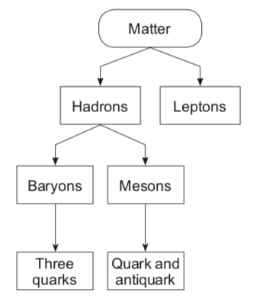

A kaon is a subatomic particle first detected in cosmic rays in 1947. There are four types:

**K−** a negatively-charged particle consisting of a strange quark and an up antiquark

**K+** a positively-charged antiparticle of the **K−** kaon

**K0** a neutrally-charged particle consisting of a strange antiquark and a down quark

**K0−** the antiparticle of the **K0**.

(a)   Are kaons classified as baryons or mesons? (1 mark)

(b)   Justify your answer to part (a). (2 marks)

(c)   Name the quarks that make up the K0− particle. (2 marks)

(d) K− particles have a mean lifetime of 1.238 × 10−8 s in their own frame of reference. Kaons produced in a particle accelerator were found to be moving at 0.850*c*. Calculate their mean lifetime in the frame of reference of a stationary observer. (3 marks)

Kaons were produced in the Tevatron, a particle accelerator in the United States. Protons were accelerated in a linear accelerator (LINAC) containing a strong electric field. Then they were injected into the circular main injector ring to be accelerated to energies of up to

1.00 TeV.

(e) With the use of appropriate equations, explain how the protons were:

(i)   accelerated to high speeds in the linear accelerator. (2 marks)

(ii)   held in circular paths in the main ring. (2 marks)